**Omni-App User Guide**

**Screen Guide:**

Main Menu GUI: Weather GUI:

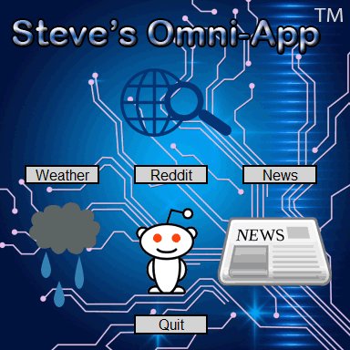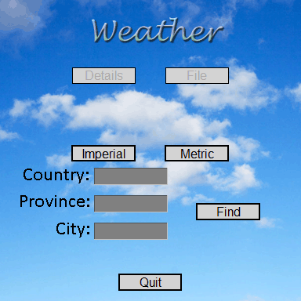

**E**

**D**

**C**

**B**

**A**

**A**

**C**

**B**

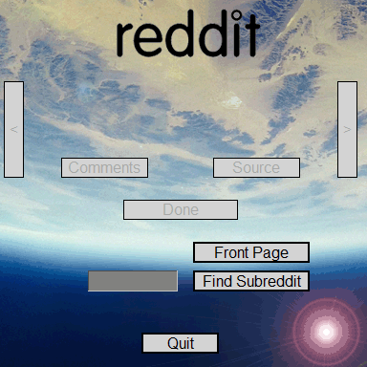

**J**

**I**

**H**

**G**

**F**

**D**

Reddit GUI: News GUI:

**G**

**D**

**C**

**A**

**B**

**F**

**D**

**C**

**B**

**A**



**I**

**H**

**F**

**E**

**J**

**I**

**G**

**H**

**E**

**Screen 1: Main Menu**

There are four buttons in this GUI. The three buttons in the middle are, in order, Weather (A), Reddit (B), and News (C). The button on the bottom is to quit the application (D). Click the Weather button to open the weather GUI, the Reddit button to open the Reddit GUI, and click the News button to open the news GUI. Note that it is not possible to have two applications running at once like having both the Weather GUI and the News GUI open at the same time. The quit button has the same function across all applications, it will immediately close the window so it will only be mentioned once.

**Screen 2: Weather**

This screen has 6 buttons and three entry boxes. The top four buttons in the upper half of the GUI, in order, are details (A), file (B), imperial (C), and metric (D). The space in the middle (E) will display weather information about an entered area. The three entry boxes (F) (G) (H) are to type in the area for weather information. The find button (I) will, upon click, try to find weather info for the entered area.

1. Enter the area you want in the three entry boxes making sure to always fill in the city box.

*Note: You can click the imperial or metric button at any time to change units. As well, WeatherSpark can accept non-traditional types of input such as airport codes. Even what look likes gibberish, WeatherSpark can interpret. Just click details for more information.*

1. Click find to find weather data. If no matches were found an error displays.

*Note: There may be lag accessing WeatherSpark. Please be patient.*

1. The find button will grey out and the details and file button will activate. At this point you can choose to write the information displayed to a file or click details to open a web browser to Weatherspark.com for more information.

*Note: You cannot proceed without writing to a file and the file is named Weather Information.txt in the same folder.*

1. Repeat from step one as desired or click quit to close the window.

*Note: Weather Information.txt is only viewable once the window is closed.*

**Screen 3: Reddit**

This screen has 6 buttons and a single entry box. The top five buttons in the upper half of the GUI, in order, are back (A), next (B), comments (C), source (D), done (E), and blank space (F) for score and headlines. There are two buttons to the left of the entry box, front page (F) and find subreddit (G). The entry box (H) is to enter the name of a subreddit.

1. Click front page to get results for the front page of Reddit or enter a subreddit in the entry box and click find subreddit.

*Note: There is no need to enter /r at the beginning of the subreddit name. This has already been done. There may be lag accessing Reddit. Please be patient.*

1. At this point, the front page and find subreddit buttons deactivate and the buttons in the upper half of the GUI activate. Use the next and back buttons to navigate the results, or click the comments or source button to open a web browser to view Reddit comments or the source material. The headline and the number of upvotes will be displayed in the blank space.

*Note: If source material is a Reddit thread, the comments and source button lead to the same site.*

1. Click the done button when you done viewing the subreddit.
2. Repeat from step one or click the quit button to close the window.

*NOTE: Steve cannot be held responsible for content viewed or available on Reddit through this app.*

**Screen 4: News**

This screen has 7 buttons with an additional 8 button to choose topics of interest. The top six buttons in the upper half of the GUI, in order, are back (A), next (B), full article (C), done (D), headlines (E), more headlines (F) and blank space (G) for news headlines. The block of eight buttons (H) is for choosing a topic of interest.

1. Click one of the eight topics of interest. At this point the eight buttons deactivate and the headlines and more headlines buttons activate.

*Note: There may be lag accessing CBC News. Please be patient.*

1. Click either headlines for large news grabbing headlines or click more headlines for smaller headlines.
2. Headlines and smaller headlines deactivate and the other buttons in the upper half of the GUI activate. Use the navigational buttons to move through the headlines or click full article to read the headline in depth by opening a web browser. Headlines will appear in the blank space (G).
3. When you are done viewing headlines click the done button.
4. Repeat from step one or click the quit button to close the window.

**####IMPORTANT####**

This program requires the installation of the Requests and Beautiful Soup module to the local Python installation or else it won’t work.

Link to Requests: <https://pypi.python.org/pypi/requests#downloads>

Link to Beautiful Soup: <https://pypi.python.org/pypi/beautifulsoup4/4.4.1>